PROJECT DOCUMENTATION
LIBSPACE

1.INTRODUCTION :
- TITLE: SmartLib API – A Backend System for Managing Library Resources
- TEAM ID: SWTID-2026-6597
- TEAM LEADER: Reshma S &sathyabalan112018@gmail.com
- TEAM MEMBERS:
- Vidya Varshini S & varshaasuresh2007@gmail.com
- Varunikaa P & vvarunikaa2006@gmail.com
- Akshaya N & akshayanithyaprakash@gmail.com

2.PROJECT OVERVIEW:
LibSpace is a backend-based library management system developed to demonstrate user authentication and book management using RESTful APIs. The system allows users to securely register, log in, and manage their personal library collection through various API endpoints.

The main purpose of the LibSpace project is to understand how backend systems work, including authentication mechanisms, database operations, and API communication between client and server. It provides a structured approach to building scalable backend applications using modern technologies such as Node.js, Express.js, and MongoDB.

The application enables users to perform complete CRUD operations on books. Once a user is authenticated, they can add new books, view their existing books, update book information, or remove books from the system. Each book is associated with a specific user, ensuring that users can only manage their own data.

This project also focuses on implementing secure authentication using JSON Web Tokens (JWT), password encryption using bcrypt, and proper route protection using middleware. Overall, LibSpace demonstrates best practices in backend development, API design, and database integration.

3. PROJECT OBJECTIVES:
The primary objective of the LibSpace project is to build a secure and efficient backend system that handles user authentication and book management functionalities.

Another important objective is to help developers understand how to design and implement RESTful APIs in a structured manner. The project demonstrates how to separate application logic into different layers such as routes, controllers, and database models.

The project also aims to provide practical knowledge of connecting backend applications with databases. By using MongoDB with Mongoose, developers can learn how to define schemas, manage relationships between collections, and perform CRUD operations effectively.

Security is also a key focus of this project. Sensitive information such as passwords are encrypted using hashing algorithms, and access to protected routes is controlled using JWT authentication.

Through this project, developers gain hands-on experience in backend architecture, API testing using Postman, error handling, and debugging techniques.

4.SYSTEM ARCHITECTURE:
LibSpace follows a layered backend architecture that separates the application into different functional layers. This approach helps in organizing code, improving maintainability, and making the application easier to scale in the future.
The system architecture consists of three main layers: API Layer, Business Logic Layer, and Data Access Layer.API Layer (Routes)The API layer is responsible for handling incoming HTTP requests from the client.
This layer defines the endpoints through which users interact with the system.Routes are implemented using Express.js and are organized into separate route files for better structure.
The routes map specific URLs to corresponding controller functions that process the requests.
This layer also manages HTTP methods such as GET, POST, PUT, and DELETE, which correspond to different operations like retrieving data, creating data, updating data, and deleting data.
Middleware is also applied at this layer to verify authentication tokens and ensure that only authorized users can access protected routes.
Business Logic Layer (Controllers)
The controller layer contains the main application logic. It acts as an intermediary between routes and the database.Controllers handle user registration, login authentication, password encryption, and book management operations.
They validate incoming request data, process the necessary logic, and send appropriate responses back to the client.For example, during user registration, the controller validates the input fields, hashes the password using bcrypt, and stores the user information in the database.
Similarly, when a user logs in, the controller verifies credentials and generates a JWT token.

Data Access Layer (Models / Database)
The data access layer manages interactions with the database.

It defines how data is structured and stored using schemas and models.MongoDB is used as the primary database for the LibSpace project.

Mongoose is used as an Object Data Modeling (ODM) library that simplifies database interactions.

The application contains two main collections: Users and Books. Each collection has its own schema that defines the structure of stored data.
The models are used to perform operations such as creating, retrieving, updating, and deleting documents from the database.

5.KEY FEATURES :
LibSpace provides several important features that ensure efficient library management and secure user authentication.
User Authentication
The system allows users to create accounts using a registration process where they provide their name, email address, and password. Passwords are securely stored in the database using hashing techniques to prevent unauthorized access.
Users can log in using their credentials, and upon successful authentication, the system generates a JSON Web Token.
This token is used to verify user identity for future requests.The system also allows users to log out and delete their accounts permanently if they no longer wish to use the platform.
Book Management (CRUD Operations)
The system enables users to manage their personal book collection through CRUD operationsUsers can add new books by providing details such as title, author, and book URL.
They can also retrieve a list of all books associated with their account.In addition, users can update the details of an existing book or delete books that are no longer needed.
All book operations are protected and can only be accessed by authenticated users.
User–Book Relationship
The application maintains a one-to-many relationship between users and books. This means that one user can have multiple books stored in the system, while each book belongs to a single user.
This relationship is implemented using MongoDB ObjectId references, which ensures proper data association and integrity.

Security and Validation
Security is an important aspect of the LibSpace system. All protected routes require a valid authentication token to access.Input validation is also implemented to ensure that required fields are provided and that invalid data does not enter the system. Error handling mechanisms are implemented to manage exceptions and provide meaningful responses to the client.

6.TECHNOLOGY STACK:
The LibSpace project uses modern backend technologies that are widely used in web development.

Node.js is used as the runtime environment for executing server-side JavaScript code.Express.js is used as the web framework to build RESTful APIs and manage routing.

MongoDB is used as the NoSQL database to store user and book information.Mongoose is used as an ODM library to define schemas and interact with MongoDB easily.

JWT (JSON Web Token) is used for implementing secure authentication.
bcrypt is used to encrypt user passwords before storing them in the database.
Postman is used for testing API endpoints during development.

7.DATABASE DESIGN :
The LibSpace system stores data in MongoDB using two main collections: Users and Books.

The Users collection stores information about registered users, including their name, email address, and encrypted password. It also stores timestamps indicating when the account was created and last updated.

The Books collection stores details about books added by users. Each book document includes information such as title, author, URL, and a reference to the user who added the book.

By using ObjectId references, MongoDB maintains a clear relationship between users and their books. This design ensures that users can only access and manage their own data.

8.API ENDPOINTS :
The backend provides several API endpoints that allow clients to interact with the system.

User-related endpoints include registration, login, logout, and account deletion. These endpoints manage user authentication and account lifecycle.

Book-related endpoints allow users to add books, retrieve books, update book information, and delete books. These endpoints are protected and require a valid authentication token.

The API follows REST principles and uses standard HTTP methods to perform operations.
USER REGISTER METHOD :
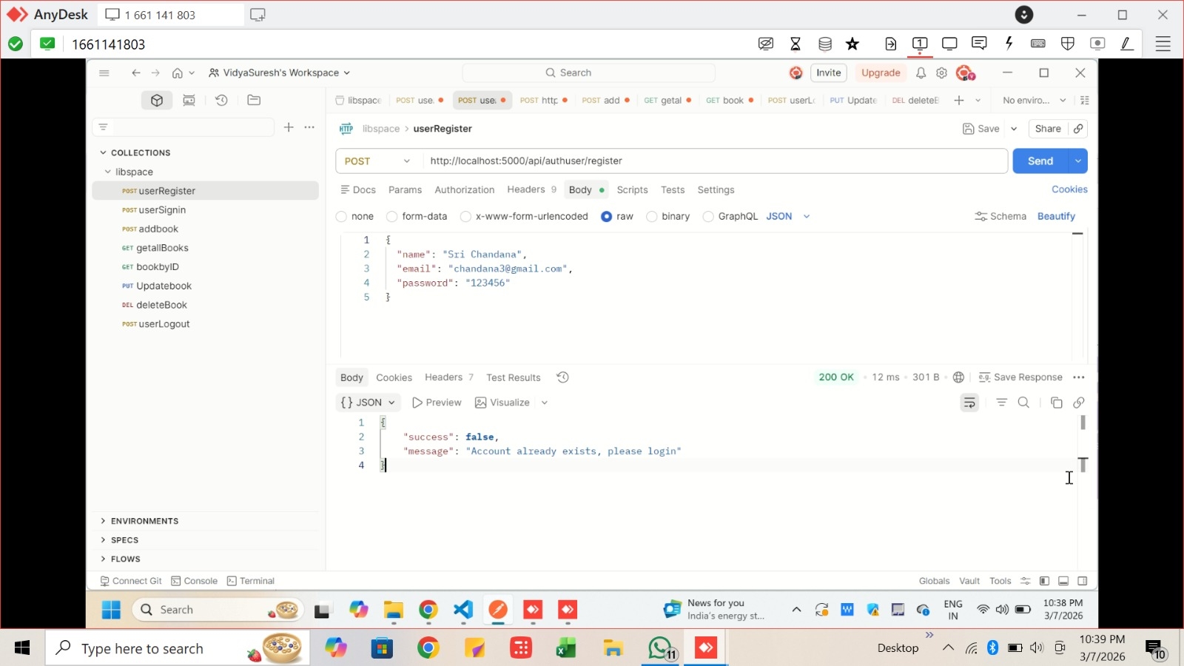

USER SIGNIN METHOD:
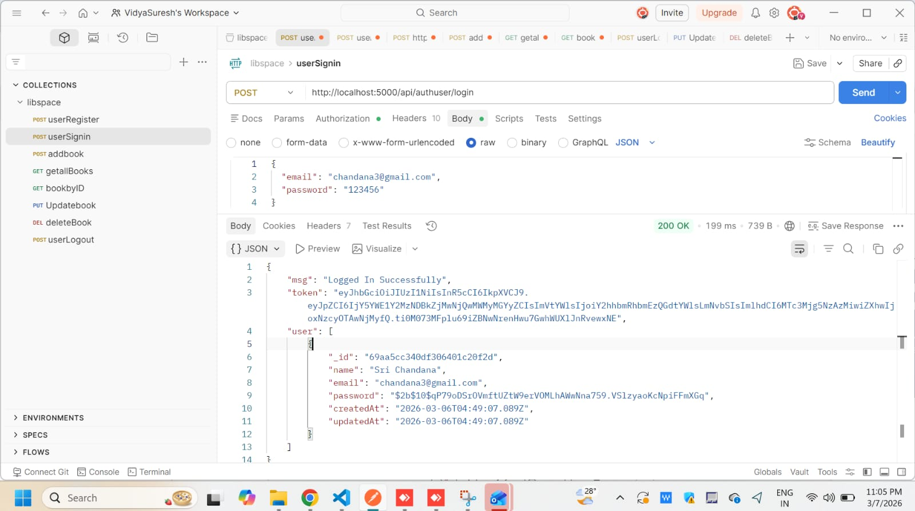

USER LOGOUT :
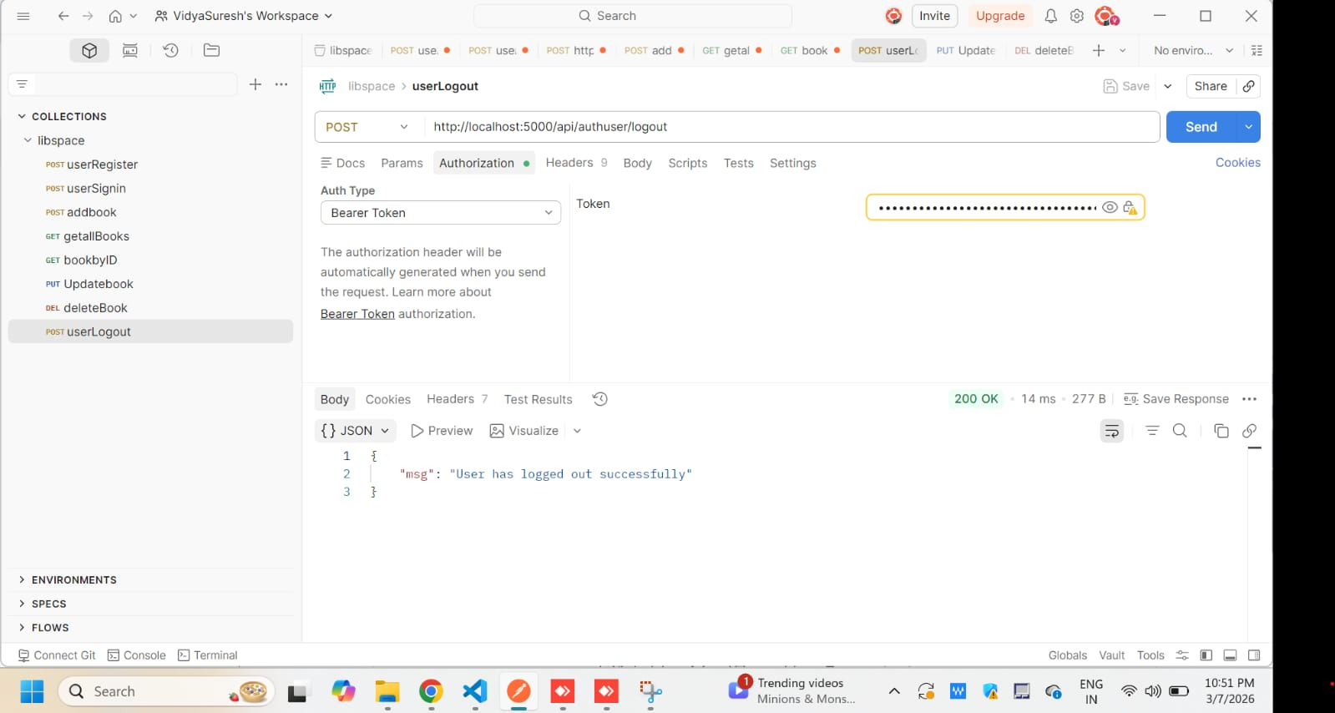
9.PROJECT EXECUTION:
To run the LibSpace backend system, developers must first install all required dependencies using npm. Once the dependencies are installed, environment variables must be configured to store sensitive information such as the database connection string and JWT secret key.

After configuring the environment variables, the MongoDB database must be started and connected to the application.

Finally, the server can be started using npm start or nodemon. Once the server is running, API endpoints can be tested using Postman or similar tools.

The application runs on the local server and can be accessed using the base URL:

http://localhost:5000

10.CONCLUSION:
LibSpace is a simple yet powerful backend application that demonstrates how to build secure RESTful APIs for a library management system.
The project highlights important backend concepts such as authentication, database management, API routing, and layered architecture.

By implementing user authentication and CRUD operations for books, the system provides a complete example of how backend applications manage user data and interactions.

Overall, LibSpace serves as a practical learning project for understanding backend development using Node.js, Express.js, and MongoDB while following best practices for security, scalability, and maintainability.
ATTACHMENTS:
1.DEMOLINK: https://drive.google.com/drive/folders/1140aLXtj6diWpxV9ZlXNr9jgtutRqF3N

